PRACTICE QUESTIONS

--TASK-1 CREATE DATABASE

CREATE DATABASE shopease_db;
USE shopease_db;

-- STEP 2: CREATE CUSTOMERS TABLE
-- Stores customer information

CREATE TABLE customers (
customer_id INT PRIMARY KEY,
first_name VARCHAR(50) NOT NULL,
last_name VARCHAR(50) NOT NULL,
email VARCHAR(100) UNIQUE NOT NULL,
city VARCHAR(50) NOT NULL,
state VARCHAR(50) NOT NULL,
join_date DATE NOT NULL,
is_premium BOOLEAN DEFAULT FALSE
);
-- Index for filtering by city/state
CREATE INDEX idx_customers_city ON customers(city);
CREATE INDEX idx_customers_state ON customers(state);
SHOW TABLES;

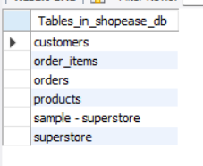

-- ========== INSERT: customers ==========
INSERT INTO customers VALUES

(101, 'Aarav', 'Sharma', 'aarav.s@email.com', 'Mumbai', 'Maharashtra', '2024-01-15', TRUE),
(102, 'Priya', 'Patel', 'priya.p@email.com', 'Ahmedabad', 'Gujarat', '2024-02-20', FALSE),
(103, 'Rohan', 'Gupta', 'rohan.g@email.com', 'Delhi', 'Delhi', '2024-03-10', TRUE),
(104, 'Sneha', 'Reddy', 'sneha.r@email.com', 'Hyderabad', 'Telangana', '2024-04-05', FALSE),
(105, 'Vikram', 'Singh', 'vikram.s@email.com', 'Jaipur', 'Rajasthan', '2024-05-12', TRUE),
(106, 'Ananya', 'Iyer', 'ananya.i@email.com', 'Chennai', 'Tamil Nadu', '2024-06-18', FALSE),
(107, 'Karan', 'Mehta', 'karan.m@email.com', 'Pune', 'Maharashtra', '2024-07-22', TRUE),
(108, 'Divya', 'Nair', 'divya.n@email.com', 'Kochi', 'Kerala', '2024-08-30', FALSE);
DESC customers;
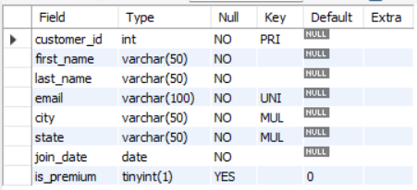

SELECT * FROM customers;

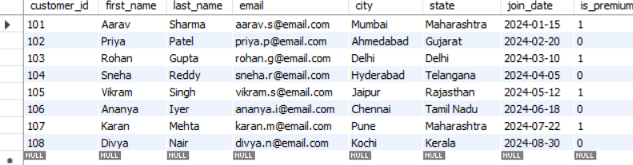

-- STEP 4: CREATE PRODUCTS TABLE
-- Stores product details and inventory

CREATE TABLE products (
product_id INT PRIMARY KEY,
product_name VARCHAR(100) NOT NULL,
category VARCHAR(50) NOT NULL,
brand VARCHAR(50) NOT NULL,
unit_price DECIMAL(10,2) NOT NULL CHECK (unit_price > 0),
stock_qty INT NOT NULL DEFAULT 0 CHECK (stock_qty >= 0)
);
-- Index for filtering by category
CREATE INDEX idx_products_category ON products(category);
DESC products;

-- ========== INSERT: products ==========
INSERT INTO products VALUES
(201, 'Wireless Earbuds', 'Electronics', 'BoAt', 1499.00, 250),
(202, 'Cotton T-Shirt', 'Clothing', 'Levis', 799.00, 500),
(203, 'Smart Watch', 'Electronics', 'Noise', 2999.00, 150),
(204, 'Running Shoes', 'Clothing', 'Nike', 4599.00, 120),
(205, 'Bluetooth Speaker', 'Electronics', 'JBL', 3499.00, 200),
(206, 'Bedsheet Set', 'Home', 'Spaces', 1299.00, 300),
(207, 'Laptop Stand', 'Electronics', 'AmazonBasics', 899.00, 180),
(208, 'Cushion Covers (Set)', 'Home', 'HomeCenter', 599.00, 400);
DESC products;
SELECT * FROM products;

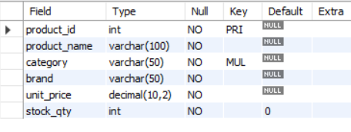

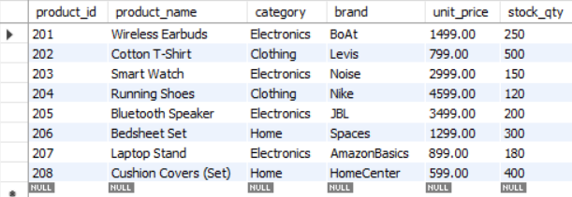
-- =====================================================
-- STEP 6: CREATE ORDERS TABLE
-- Stores customer order information
-- =====================================================
CREATE TABLE orders (
order_id INT PRIMARY KEY,
customer_id INT NOT NULL,
order_date DATE NOT NULL,
status VARCHAR(20) NOT NULL DEFAULT 'Pending'
CHECK (status IN ('Pending','Shipped','Delivered','Cancelled')),
total_amount DECIMAL(12,2) NOT NULL CHECK (total_amount >= 0),

FOREIGN KEY (customer_id) REFERENCES customers(customer_id)
);
-- Index for date-based filtering and sorting
CREATE INDEX idx_orders_date ON orders(order_date);
CREATE INDEX idx_orders_status ON orders(status);

-- ========== INSERT: orders ==========

INSERT INTO orders VALUES
(1001, 101, '2024-08-01', 'Delivered', 4498.00),
(1002, 102, '2024-08-03', 'Delivered', 799.00),
(1003, 103, '2024-08-05', 'Shipped', 7498.00),
(1004, 101, '2024-08-10', 'Delivered', 3499.00),
(1005, 104, '2024-08-12', 'Cancelled', 2999.00),
(1006, 105, '2024-08-15', 'Delivered', 5898.00),
(1007, 106, '2024-08-18', 'Pending', 1299.00),
(1008, 103, '2024-08-20', 'Delivered', 899.00),
(1009, 107, '2024-08-25', 'Shipped', 6098.00),
(1010, 108, '2024-08-28', 'Delivered', 1598.00);
DESC orders;
SELECT * FROM orders;
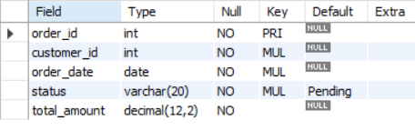

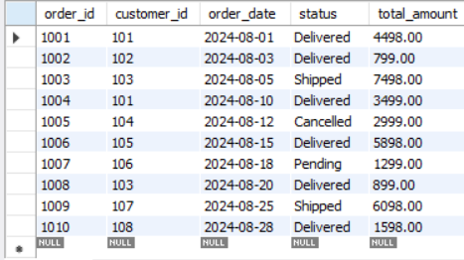

-- STEP 8: CREATE ORDER_ITEMS TABLE
-- Stores products included in each order

CREATE TABLE order_items (
item_id INT PRIMARY KEY,
order_id INT NOT NULL,
product_id INT NOT NULL,
quantity INT NOT NULL CHECK (quantity > 0),
unit_price DECIMAL(10,2) NOT NULL CHECK (unit_price > 0),
discount_pct DECIMAL(5,2) DEFAULT 0 CHECK (discount_pct BETWEEN 0 AND 100),

FOREIGN KEY (order_id) REFERENCES orders(order_id),
FOREIGN KEY (product_id) REFERENCES products(product_id)
);
SHOW TABLES;

-- ========== INSERT: order_items ==========

INSERT INTO order_items VALUES
(5001, 1001, 201, 2, 1499.00, 0),
(5002, 1001, 207, 1, 899.00, 10),
(5003, 1002, 202, 1, 799.00, 0),
(5004, 1003, 203, 1, 2999.00, 0),
(5005, 1003, 204, 1, 4599.00, 5),
(5006, 1004, 205, 1, 3499.00, 0),
(5007, 1005, 203, 1, 2999.00, 0),
(5008, 1006, 201, 1, 1499.00, 10),
(5009, 1006, 204, 1, 4599.00, 5),
(5010, 1007, 206, 1, 1299.00, 0),
(5011, 1008, 207, 1, 899.00, 0),
(5012, 1009, 205, 1, 3499.00, 0),
(5013, 1009, 208, 2, 599.00, 15),
(5014, 1010, 206, 1, 1299.00, 0),
(5015, 1010, 208, 1, 599.00, 0);
DESC order_items;
SELECT * FROM order_items;

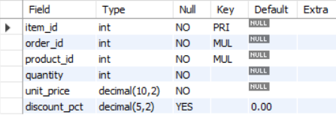

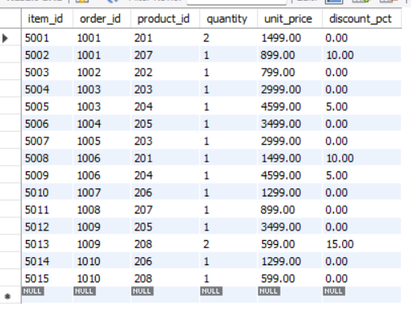

Section A — SQL Basics (SELECT, Constraints, Primary Keys)

Q1) Write a query to display all columns and rows from the customer's table.

SELECT * FROM customers;
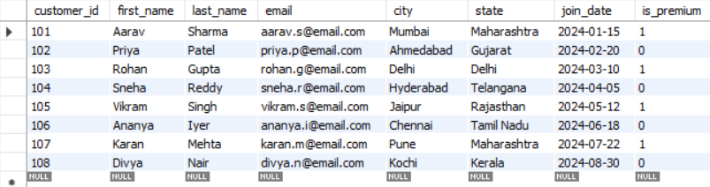

-- Q2. Retrieve only the first_name, last_name, and city of all customers.

SELECT first_name, last_name, city FROM customers;
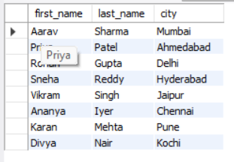

-- Q3. List all unique categories available in the products table.

SELECT DISTINCT category FROM products;

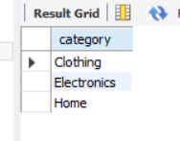

-- Q4: Identify the Primary Key of each table in the schema.

Primary Keys:
-- customers table -> customer_id
-- products table -> product_id
-- orders table -> order_id
-- order_items table -> item_id
- A Primary Key is a column that uniquely identifies each record in a table.
- It helps ensure that duplicate records are not created and maintains data integrity. Primary Key values must be unique and cannot contain NULL values.
- They also play an important role in connecting related tables through relationships, making data retrieval and management more efficient.
-- Q5: What constraints are applied to the email column in the customers table? What happens if a duplicate email is inserted?
-- Step 1: Check constraints on the customers table
DESC customers;
- The email column is defined with:
UNIQUE -> prevents duplicate email addresses
NOT NULL -> ensures every customer has an email
-- Step 2: Try inserting a customer with an existing email
INSERT INTO customers
VALUES (
109,
'Test',
'User',
'aarav.s@email.com',
'Mumbai',
'Maharashtra',
'2024-09-01',
TRUE
);
-- Expected Result:
-- MySQL will return an error similar to:
-- ERROR 1062 (23000): Duplicate entry 'aarav.s@email.com'
-- for key 'customers.email'

-- Explanation:
-- The email column has a UNIQUE constraint, which means each customer must have a different email address.
-- It also has a NOT NULL constraint, ensuring that no customer record can be created without an email.

-- When attempting to insert an email that already exists in the table, MySQL rejects the operation and displays a duplicate entry error.
-- These constraints help maintain data quality, preven duplicate customer accounts, and ensure accurate records.
-- Q6: Try inserting a product with unit_price = -50. What happens and which constraint prevents it?
-- Step 1: Attempt to insert a product with a negative price
INSERT INTO products
VALUES (
209,
'Test Product',
'Electronics',
'TestBrand',
-50,
100
);
-- Expected Result:
-- The insertion will fail and MySQL will return an error because the unit_price value is negative.
-- Constraint Responsible:
-- CHECK (unit_price >0)
-- Explanation:
-- The products table contains a CHECK constraint on the unit_price column that ensures product prices must be greater than zero.
-- Since -50 is an invalid price, the database rejects the record and prevents it from being inserted.
-- Importance:
-- This constraint helps maintain data accuracy by ensuring
-- that products cannot have negative or unrealistic prices.
-- It also protects business reports and calculations from
-- incorrect data being stored in the database.

SECTION B — FILTERING & OPTIMIZATION (WHERE, INDEXES)
Q7. Retrieve all orders with status = 'Delivered’
SELECT * FROM orders WHERE status = 'Delivered';
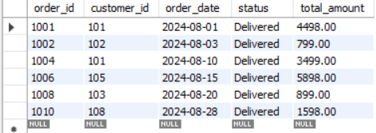

Explanation

This query retrieves all orders that have been successfully delivered to customers. Only completed transactions are returned, making the result useful for revenue analysis and sales reporting.

Business Insight
Delivered orders represent successfully completed sales and can be used to measure actual business revenue.

-- Q8. Find all products in the 'Electronics' category with a unit_price greater than ₹2000.
SELECT product_id,product_name,brand,unit_price,stock_qty
FROM products
WHERE category = 'Electronics' AND unit_price > 2000
ORDER BY unit_price DESC;
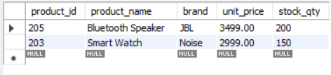
The query filters products belonging to the Electronics category and returns only premium products priced above ₹2000.

Business Insight
High-value electronic products typically contribute more revenue per transaction and are important for profitability analysis
-- Q9. List all customers who joined in the year 2024 and belong to the state 'Maharashtra'.
SELECT customer_id, first_name, last_name, email, city, state, join_date FROM customers WHERE state = 'Maharashtra' AND join_date >= '2024-01-01' AND join_date < '2025-01-01' ORDER BY join_date;
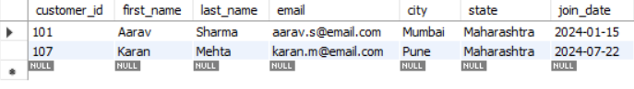
This query retrieves customers from Maharashtra who joined during 2024.

Optimization Note
Using a date range is more efficient than YEAR(join_date)=2024 because it allows the database to utilize indexes effectively.

Business Insight
The result helps analyze customer acquisition in Maharashtra during the specified year.
-- Q10. Find all orders placed between '2024-08-10' and '2024-08-25' (inclusive) that are NOT cancelled.
SELECT * FROM orders WHERE order_date BETWEEN '2024-08-10' AND '2024-08-25' AND status <> 'Cancelled';
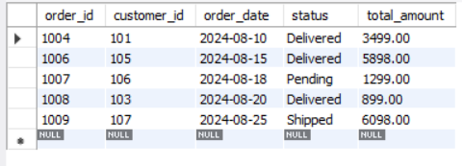
-- Q11. Explain what the index idx_orders_date does. How would it improve the performance of a query that filters orders by order_date? Write a sample query that would benefit from this index.

Index Definition
CREATE INDEX idx_orders_date
ON orders(order_date);

Query Benefiting from the Index
SELECT
order_id,
customer_id,
total_amount
FROM orders
WHERE order_date BETWEEN '2024-08-01' AND '2024-08-31';
The idx_orders_date index is created on the order_date column to speed up date-based searches.
Without the index:
- MySQL performs a Full Table Scan.
- Every row must be checked individually.
With the index:
- MySQL directly navigates to matching date values.
- Fewer rows are scanned.
- Query execution becomes faster.
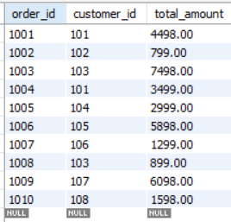
Q12. If you run:SELECT * FROM customersWHERE YEAR(join_date) = 2024;Would the index on join_date be used?
No, the index on join_date would not be used efficiently.

Reason
The YEAR() function is applied directly to the indexed column (join_date). Before MySQL can evaluate the condition, it must calculate the year for every row in the table. As a result, the database cannot effectively use the index and may perform a full table scan.
This type of query is called Non-SARGable (Search Argument Not Able).

Index-Friendly (SARGable) Query
SELECT *
FROM customers
WHERE join_date >= '2024-01-01'
AND join_date < '2025-01-01';

Why is this better?
The rewritten query compares the column directly against a date range without applying any function. This allows MySQL to use the index on join_date efficiently, resulting in faster query execution and better performance on large datasets.

Section C — Aggregation (GROUP BY, SUM, COUNT, AVG, MIN, MAX)

Q13. Count the total number of orders in the orders table
SELECT COUNT(*) AS Total_Orders
FROM orders;
COUNT(*) returns the total number of records present in the orders table.

Business Insight
This helps measure overall transaction volume and business activity.
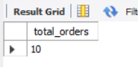

Q14. Find the total revenue from all Delivered orders
SELECT ROUND(SUM(total_amount), 2) AS Total_Revenue
FROM orders
WHERE status = 'Delivered';
SUM(total_amount) calculates the total revenue generated from successfully delivered orders.

Business Insight
Delivered orders represent completed sales and actual realized revenue.
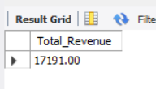
-- Q15. Calculate the average unit_price of products in each category.
SELECT category,
AVG(unit_price) AS average_price
FROM products
GROUP BY category;
The query groups products by category and calculates the average product price within each category.

Business Insight
This helps compare pricing levels across product categories.
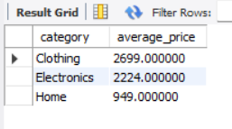

Q16. For each order status, find the count of orders and total revenue
SELECT status,
COUNT(*) AS Total_Orders,
ROUND(SUM(total_amount), 2) AS Total_Revenue
FROM orders
GROUP BY status
ORDER BY Total_Revenue DESC;
Orders are grouped by status and summarized using COUNT and SUM functions.

Business Insight
This helps understand how revenue is distributed across different order stages.
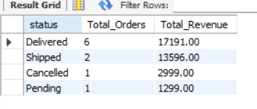

Q17. Find the most expensive and cheapest product in each category
SELECT category,
MAX(unit_price) AS Highest_Price,
MIN(unit_price) AS Lowest_Price
FROM products
GROUP BY category;
MAX() identifies the highest-priced product and MIN() identifies the lowest-priced product within each category.

Business Insight
Useful for understanding product pricing ranges and category positioning.
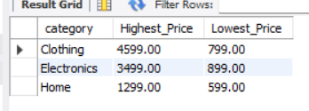

Q18. List product categories where average unit price is greater than ₹2000
SELECT category,
ROUND(AVG(unit_price), 2) AS Average_Price
FROM products
GROUP BY category
HAVING AVG(unit_price) > 2000;
The HAVING clause filters grouped results and returns only categories with an average price above ₹2000.

Business Insight
These categories generally contain premium products and contribute higher revenue per sale.
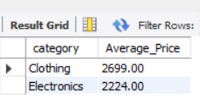

Section D — Joins & Relationships

Q19. Display each order along with the customer's first name and last name
SELECT
o.order_id,
o.order_date,
c.first_name,
c.last_name,
o.total_amount
FROM orders o
INNER JOIN customers c
ON o.customer_id = c.customer_id;
The INNER JOIN combines records from the orders and customers tables using the customer_id column. Only matching records from both tables are returned.

Business Insight
This query helps identify which customer placed each order and is useful for customer-level sales analysis.
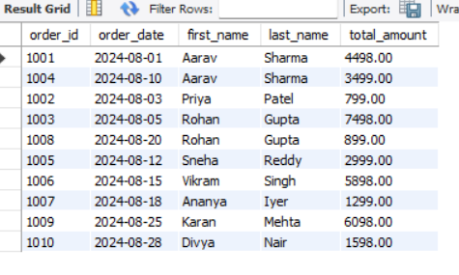

Q20. List all customers and their orders using LEFT JOIN
SELECT
c.customer_id,
c.first_name,
c.last_name,
o.order_id,
o.order_date,
o.status
FROM customers c
LEFT JOIN orders o
ON c.customer_id = o.customer_id;
The LEFT JOIN returns all customers, including those who have never placed an order. If a customer has no order, the order-related columns will contain NULL values.

Business Insight
This helps identify inactive customers and customers who have not yet made a purchase.
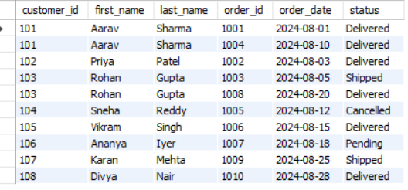

Q21. Show order details with product information
SELECT
o.order_id,
p.product_name,
oi.quantity,
oi.unit_price,
oi.discount_pct
FROM orders o
INNER JOIN order_items oi
ON o.order_id = oi.order_id
INNER JOIN products p
ON oi.product_id = p.product_id
ORDER BY o.order_id;
This query joins three tables: Orders,order_items,products

Business Insight
This query is useful for analyzing product sales, discounts, and customer purchasing patterns.
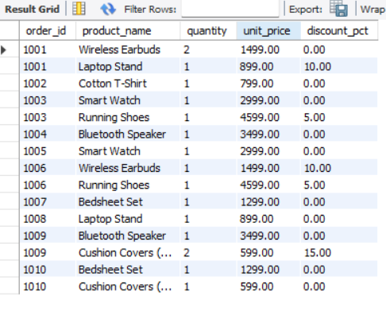

Q22. Difference Between LEFT JOIN and RIGHT JOIN

LEFT JOIN Example
SELECT
c.customer_id,
c.first_name,
o.order_id
FROM customers c
LEFT JOIN orders o
ON c.customer_id = o.customer_id;
Returns all customers, even if they have not placed any orders.
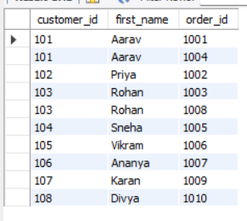

RIGHT JOIN Example
SELECT
c.customer_id,
c.first_name,
o.order_id
FROM customers c
RIGHT JOIN orders o
ON c.customer_id = o.customer_id;
Returns all orders, even if customer information is missing.
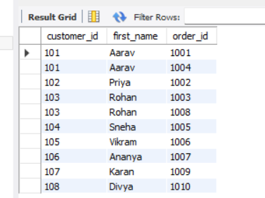

Key Difference
- LEFT JOIN keeps all records from the left table.
- RIGHT JOIN keeps all records from the right table.

When to Use FULL OUTER JOIN
A FULL OUTER JOIN returns:
- All records from the left table
- All records from the right table
- Matching records where available
It is useful when you want to identify unmatched records from both tables simultaneously.

Business Insight
FULL OUTER JOIN is commonly used in data auditing, reconciliation, and data quality validation.

Q23. Identify Foreign Key Relationships

Foreign Key Relationships
- orders.customer_id
→ references customers.customer_id
- order_items.order_id
→ references orders.order_id
- order_items.product_id
→ references products.product_id

Relationship Structure
customers (1) orders
orders (1) order_items
products (1) order_items

What happens if customer_id = 999 is inserted into orders?
Example:
INSERT INTO orders
VALUES (
1011,
999,
'2024-09-01',
'Pending',
1000.00
);

Expected Result
MySQL will return a Foreign Key Constraint Error because customer_id = 999 does not exist in the customers table.
The Foreign Key constraint ensures referential integrity between related tables. It prevents orders from being created for customers that do not exist.

Business Insight
Foreign Keys maintain data consistency and prevent orphan records, ensuring accurate reporting and reliable relationships between tables.

Section E — Advanced Concepts (CASE, ACID, Transactions)

Q24. Write a query using CASE to classify products into price tiers:
• 'Budget' → unit_price < 1000
• 'Mid-Range' → unit_price BETWEEN 1000 AND 3000
• 'Premium' → unit_price > 3000
Display: product_name, unit_price, price_tierQuery
SELECT
product_name,
unit_price,
CASE
WHEN unit_price < 1000 THEN 'Budget'
WHEN unit_price BETWEEN 1000 AND 3000 THEN 'Mid-Range'
ELSE 'Premium'
END AS price_tier
FROM products
ORDER BY unit_price;
The CASE statement categorizes products into different price segments based on their unit price.

Business Insight
Price segmentation helps businesses understand product positioning and create targeted marketing strategies for different customer groups.
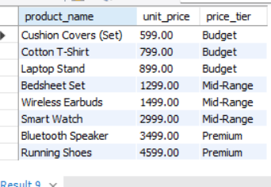

Q25. Count Delivered vs Not Delivered Orders using CASE
SELECT
SUM(
CASE
WHEN status = 'Delivered' THEN 1
ELSE 0
END
) AS Delivered_Orders,
SUM(
CASE
WHEN status <> 'Delivered' THEN 1
ELSE 0
END
) AS Not_Delivered_Orders
FROM orders;
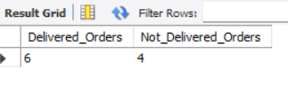

Q26. Explain ACID Properties

A — Atomicity
Atomicity means a transaction is treated as a single unit of work. Either all operations succeed or none of them are applied.
Example:
If a bank transfers ₹10,000 from Account A to Account B, both debit and credit operations must complete successfully. If one fails, the entire transaction is rolled back.

C — Consistency
Consistency ensures that data remains valid before and after a transaction.
Example:
After a money transfer, the total balance across accounts remains correct according to business rules.

I — Isolation
Isolation ensures that multiple transactions occurring simultaneously do not interfere with one another.
Example:
If two customers try to purchase the last item in stock at the same time, the database prevents conflicting updates.

D — Durability
Durability guarantees that once a transaction is committed, it remains permanently stored even if a system failure occurs.
Example:
After a successful online payment, the transaction record remains saved even if the server crashes immediately afterward.

Business Importance of ACID
ACID properties ensure:
- Reliable transactions
- Accurate financial records
- Consistent business data
- Protection against system failures
These principles are essential for banking systems, e-commerce platforms, healthcare applications, and enterprise databases.
Q27. Write a SQL transaction that does the following atomically:
1. Insert a new order (order_id=1011, customer_id=102, today's date, 'Pending', 1598.00)
2. Insert two order items for that order
3. Update the stock_qty of the purchased products
4. If any step fails, ROLLBACK the entire transaction. Otherwise, COMMIT.
Write the complete BEGIN...COMMIT/ROLLBACK block.

Query
START TRANSACTION;
-- Step 1: Create New Order
INSERT INTO orders
(order_id, customer_id, order_date, status, total_amount)
VALUES
(1011, 102, CURRENT_DATE, 'Pending', 1598.00);
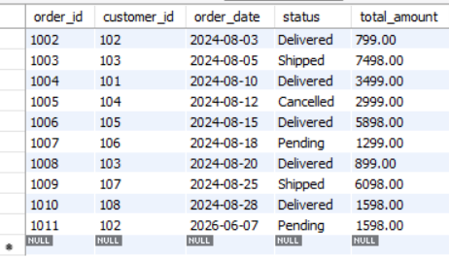
-- Step 2: Insert Order Items
INSERT INTO order_items
(item_id, order_id, product_id, quantity, unit_price, discount_pct)
VALUES
(5016, 1011, 206, 1, 1299.00, 0);
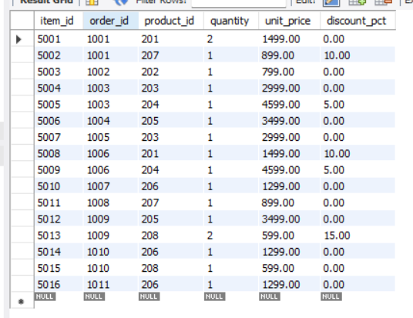
INSERT INTO order_items
(item_id, order_id, product_id, quantity, unit_price, discount_pct)
VALUES
(5017, 1011, 208, 1, 299.00, 0);
-- Step 3: Update Inventory
UPDATE products
SET stock_qty = stock_qty - 1
WHERE product_id = 206;
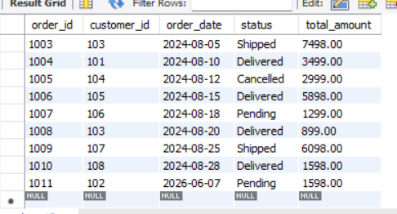
UPDATE products
SET stock_qty = stock_qty - 1
WHERE product_id = 208;
COMMIT;
If any INSERT or UPDATE operation fails:
ROLLBACK;
The transaction ensures that all related operations are executed as a single unit.
Operations included:
- Create a new order.
- Add order items.
- Reduce product inventory.
- Commit only if all steps succeed.
If any step fails, the transaction is rolled back to maintain data consistency.

Business Insight
Transactions are critical in e-commerce systems because they prevent:
- Incorrect inventory counts
- Partial order creation
- Lost sales records
- Data inconsistencies
Using transactions ensures reliable and accurate order processing.
----------------------------------------------END---------------------------------------------------

窗体底端

